Activity 14. Program Your Own Videogame (Programamos)
- Learning outcome(s): (list up to 3)
    - Develop coding and computational thinking skills.
    - Encourage personal initiative.
    - Foster reflection on diversity of users’ needs and interests.
- Relation of activity with the STEM, gender inclusiveness and Entrepreneurship: (text, not bullets, explaining the relation of the activity to 3 above)
The relation with the STEM is clear, since coding and computational thinking are key abilities of it. In terms of gender inclusiveness, the activity promotes that students reflect on the diversity of users that a game may have, users that have different needs, backgrounds and interests. Regarding entrepreneurship, the activity encourage students to create and develop a new game to satisfy such potential players’ interests.
- Indicate the area of focus:
☒ STEM
☐ Gender inclusiveness
☐ Entrepreneurship
- Materials: (including ppts, videos, hands-on material)
  - 3 videos with increasing complexity showing how to make a Space Game with Scratch:
    - https://www.youtube.com/watch?v=TAkWWWYxugY
    - https://www.youtube.com/watch?v=iPA7UssfyJg
    - https://www.youtube.com/watch?v=7ipAjoXWqE8

- Preparation:
None
- Duration: 80 (minutes)
- Target group: 12-15 (student age)
__________________________________________________________________________

- Description of the activity:
Students watch the videos at their pace and start coding a replica of the videogame (30’). Students reflect on the type of game they have created and imagine modifications on such game to serve potential users with different interests and needs (10’). Finally, students can personalize the game or create a different, personal videogame based on these reflections and taking into account some entrepreneurial issues, such as market segments and target groups (40’).

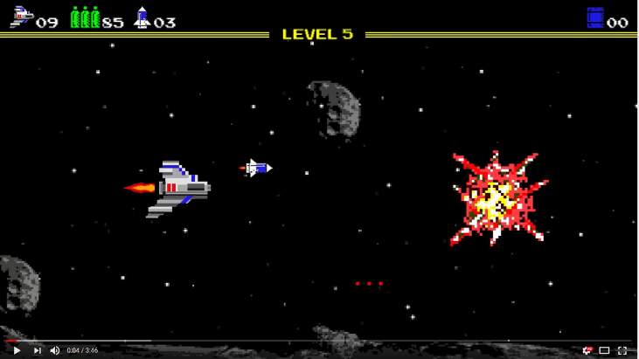

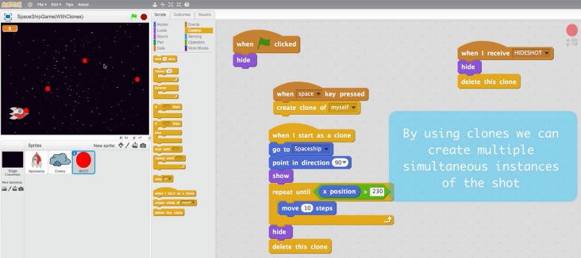
9. Link to curriculum:

