Activity 26. Research and Technology Center Visits (CYRIC)
- Learning outcome(s): (list up to 3)
    - Develop problem-solving and research skills
    - Inspire and raise awareness of STEM career paths
- Relation of activity with the STEM, gender inclusiveness and Entrepreneurship: (text, not bullets, explaining the relation of the activity to 3 above)
The activity is related with STEM as it exposes the students to an environment where the majority has a STEM background and are following a STEM related career.
- Indicate the area of focus:
☒ STEM
☐ Gender inclusiveness
☐ Entrepreneurship
- Materials: (including ppts, videos, hands-on material)
- None
- Preparation:
Teachers review the availability of Research and Technology Centers in their vicinity and arrange a visit ahead of time. Depending on location and language restrictions, teleconferences can also be arranged.
- Duration: 60-80 (minutes)
- Target group: 12-18 (student age)
__________________________________________________________________________

- Description of the activity:
The teacher and students visit local Research and Technology Center or connect via teleconference with a Center. The visit could include a tour of facilities and quick presentation of equipment in simple terms. Emphasis is placed on people, particularly allowing enough time for students to listen to researcher experiences and ask questions. The Center’s activities and applied solutions are presented to inspire and raise awareness of STEM career paths.

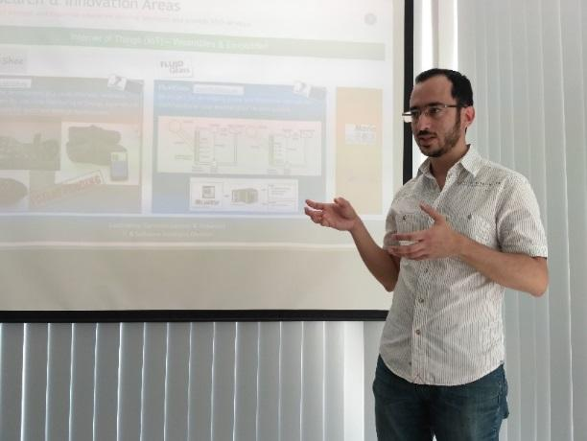
9. Link to curriculum: Science Module, Design and Technology Module

