Activity 4. Find Gender Stereotypes in STEM Representations! (ΝΕΜΟ)
- Learning outcome(s): (list up to 3)
    - Students understand what sex and gender stereotypes are and identify them. Awareness of stereotypes is heightened.
    - Increase awareness about the negative impact they can have on their own representations of sciences, the world of science and technology, and their study/career choices.
    - Learn about careers in STEM and develop an interest in them, regardless of their sex.
- Relation of activity with the STEM, gender inclusiveness and Entrepreneurship: (text, not bullets, explaining the relation of the activity to 3 above)
This activity deals with science and technology in general with a societal approach.
- Indicate the area of focus:
☒ STEM
☒ Gender inclusiveness
☐ Entrepreneurship
- Materials: (including ppts, videos, hands-on material)
- Video projector
- Flip chart
- Visual images from Google search, magazines and newspapers (try to find pictures that are relevant for the class or an actual hot topic)
- Pen or pencil
- Paper
- Post-it
- Analysis grid (Attachment 3)
- Preparation:
To prepare for the activity, facilitators will need to choose the ads that will be shown during the workshop and prepare the analysis grids that will be distributed to students. A better explanation of the particular ads can be found in the description of the activity. Closed and modular space so tables can be moved to work in small groups.
- Duration: 90 (minutes)
- Target group: 12-18 (student age)
__________________________________________________________________________

- Description of the activity:
INTRODUCTION (5 minutes)
Quick introduction explaining to students that they are going to comment on advertisements for daily technological objects and recruitment campaign visuals, followed by an analysis and discussion. The facilitator or teacher will emphasize that they are really interested in what the students think. Emphasize that this activity is in no way meant to tell each other that their own beliefs are wrong, but to train them to ge a sharper eye on the subject.
DEVELOPMENT OF THE ACTIVITY
Step one (10 minutes)
The activity begins with a question: What are the skills, ideas, adjectives or qualities that you spontaneously associate with men, boys, girls and women?
Give 2 post-its to each student: they will write what they associate with women/girls on one and what they associate with men/boys on the other.
N.B: post-its are anonymous, a very short period of time is given to write down the associations.
The post-its are then stuck on the flipchart, arranged into 2 columns: one column for words associated with women/girls and one for words associated with men/boys. They will be commented on at the end of the workshop. The person leading the workshop (the facilitator) then explains the general notion of stereotypes, clichés, preconceived ideas.
Note: definition of sex and gender stereotypes:
Sex and gender stereotypes are over-generalizations of what girls and boys/men and women are and are not, by nature: "women have no sense of direction", "men are tech-savvy", "women are intuitive", "men are not emotional", etc. How do stereotypes work? Sex and gender stereotypes legitimize the roles of each sex by "naturalizing" them: they make the different and hierarchical roles of sexes assigned to men and women seem biological and natural.

Step two (30 minutes)
The facilitator shows the first ad and the group comments on it together to give students an idea of how to analyse an image. The students are asked to form three groups, preferably mixed girls and boys. The facilitator gives each group a recent ad for a technological object (the ad is printed on a A3 coloured sheet of paper); each group receives a different visual. For example:
- an ad for a pink phone and for a blue phone
- a computer marketed for girls, and one marketed for boys
- an ad for video games showing girls and boys
Each group is given a blank analysis grid (Attachment 2). Students observe and discuss the visual, and fill in the grid.
Each group chooses a presenter. During the plenary session, each presenter explains the group's findings to the rest of the students. A group discussion follows to give everyone an opportunity to share their opinion. The facilitator can further comment if necessary and briefly explain what is meant by "gender" and sex and gender stereotypes.
The aim of this step is to highlight associations that advertisers make between technical skill and, in most cases, men; this stereotype often portrays women as incompetent or seductive, and also gives a very narrow and formatted view of masculinity.
Step three (30 minutes)
The same approach is used for the recruitment campaign visuals. Students are presented with:
- a very stereotyped visual
- a less stereotyped visual to foster debate
  - a more neutral visual in terms of sex and gender representation and, if possible, diversity, one that can be used as an example of respecting gender equality and diversity.
Attention is given to the people represented and the field or place where they are represented: for example, in a recruitment campaign for researchers of all disciplines, a woman is shown in a laboratory in the foreground, another photo shows a medium shot of a man contemplating the stars. This distinction between interior/exterior, infinitely small/infinitely large, is produced in recurring stereotypes. •Students are asked to identify and discuss the sex and gender stereotypes in the visuals, to fill in the analysis grid, and discuss their observations. The teenagers will have a sharper eye after the first step of the activity, but they will still have to consider the presence of stereotypes by themselves in these pictures and the impact they can have when they think about a career in STEM jobs. The previous grid will again help to raise their awareness.
This step will conclude with a look back at the post-its. Students will compare what was written on the post-its, i.e. women/girl and men/boy word associations:
- with the stereotypes identified in the ads for technological objects
- with the stereotypes tied to careers in science and technology
In most cases, there will be many similarities.
The facilitator asks students for their opinion and launches a discussion on the impact stereotypes have on study/career choices and the representation of careers in STEM. The facilitator emphasizes the disadvantages of stereotyping in STEM representations. They influence the choice of one's studies and career based on skills and likes/dislikes on preconceived ideas.
Step 4
CONCLUSION
The activity ends with students' general feedback on the workshop, a quick presentation of images of "role model" women that are being presented in these ads and magazines in various fields such as engineering, astronomy, video games, etc. The idea is to show students that skill and success have nothing to do with a person's sex.
Extra: In the classroom, the teacher can easily modify this activity for a younger target group:
Option 1
Use children’s magazines and ask the children to make a poster out of every magazine. They can only use one magazine per poster. Stick all posters to the wall and have a discussion with the students about what they think what the target group of each magazine is and why. Do they think this is the best way to reach out to this target group? Do they feel attracted?
Option 2
Use children’s magazines and ask the children to make a poster of something they like. They can use every magazine they want. Stick all posters to the wall and have a discussion with the students about what they see. Can they find out which poster is made by a girl and which one by a boy or do the posters pretty much alike? Are they surprised by the outcomes?
Option 3
Use grown-up magazines and ask the children to make a poster of what they think an entrepreneur looks like that works in a STEM field. Stick all posters to the wall and have a discussion: What do they see? Can they see which posters were made by a boy or a girl? Are they surprised by the outcomes?

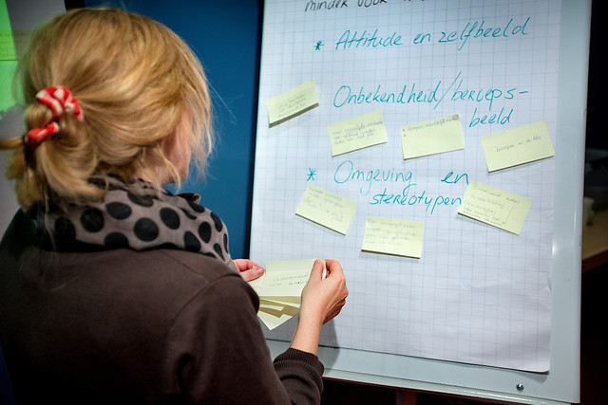
Photography: DigiDaan
9. Link to curriculum: professional orientation

